

Practices for Secure Software Report

Table of Contents
Document Revision History 3
Client 3
Instructions 3
Developer 4
1. Algorithm Cipher 4
2. Certificate Generation 4
3. Deploy Cipher 4
4. Secure Communications 4
5. Secondary Testing 4
6. Functional Testing 4
7. Summary 4
8. Industry Standard Best Practices 4

Document Revision History

Version | Date | Author | Comments
1.0 | 06/18/23 | Daniel Lucia

Client



Instructions

Submit this completed practices for secure software report. Replace the bracketed text with the relevant information. You must document your process for writing secure communications and refactoring code that complies with software security testing protocols.

- Respond to the steps outlined below and include your findings.
- Respond using your own words. You may also choose to include images or supporting materials. If you include them, make certain to insert them in all the relevant locations in the document.
- Refer to the Project Two Guidelines and Rubric for more detailed instructions about each section of the template.

Developer
Daniel Lucia

Algorithm Cipher
Recommend an appropriate encryption algorithm cipher to deploy, given the security vulnerabilities, and justify your reasoning. Review the scenario and the supporting materials to support your recommendation. In your practices for secure software report, be sure to address the following:
- Provide a brief, high-level overview of the encryption algorithm cipher.
- Discuss the hash functions and bit levels of the cipher.
- Explain the use of random numbers, symmetric versus non-symmetric keys, and so on.
- Describe the history and current state of encryption algorithms.

Artemis Financial has requested increased security for its web application to ensure it continues to have secure communications. We assume that the most probable attack that would target a financial institution is a bad actor. They would be attempting to make financial gains by accessing the sensitive information stored within the system. So, the best recommendation to protect the client would be encryption. This renders the files useless to any outside intruder attempting to steal the files without a key. As the firm seeks to secure its communications, I recommend asymmetric communications, which means that the key to encrypt is public, and the key to decrypt is private. Since this information can be sent externally, I suggest using the SHA-256 algorithm cipher with a 256-bit key to encrypt to maintain the highest level of security. The SHA-256 encryption provides an exceptionally high level of bit encryption with many different possible key combinations 256 bits in length. The SHA-256 algorithm also uses Java’s random number generator, ensuring the encryption is exceptionally secure by making a non-reversible checksum that verifies the file’s validity. The hash function then uses the SHA-256 cipher to generate a checksum of the message.

Certificate Generation
Generate appropriate self-signed certificates using the Java Keytool in Eclipse.
- To demonstrate that the certificate was correctly generated:
  - Export your certificates (CER file).
  - Submit a screenshot of the CER file in your practices for secure software report.
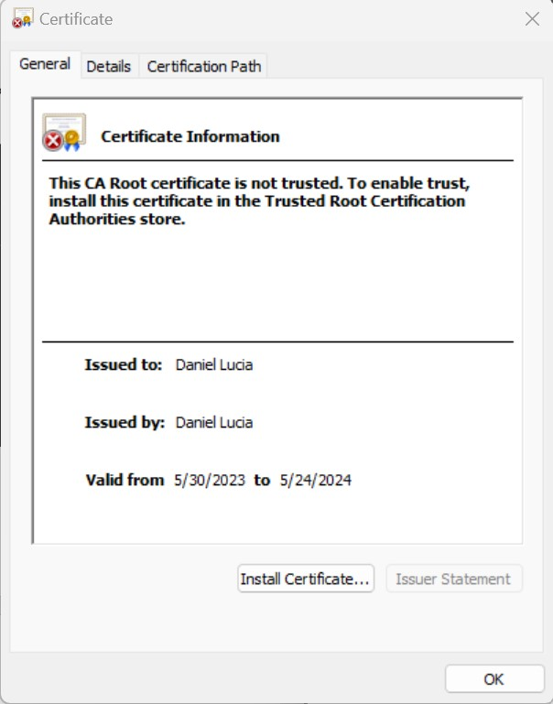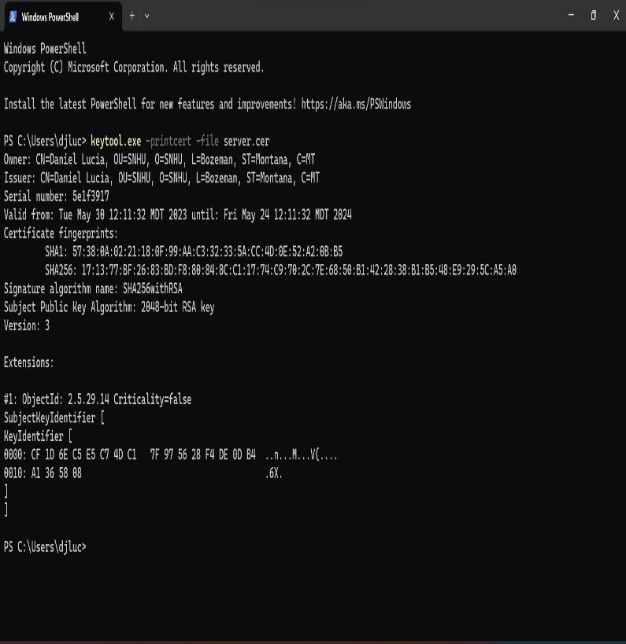

Deploy Cipher
Deploy and implement the cryptographic hash algorithm by refactoring code. Demonstrate functionality with a checksum verification.
- Submit a screenshot of the checksum verification in your practices for secure software report. The screenshot must show your name and a unique data string that has been created.
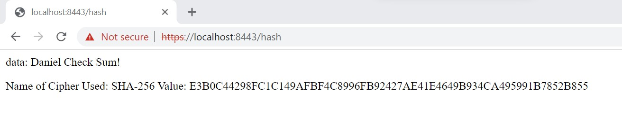

Secure Communications
Verify secure communication. In the application.properties file, refactor the code to convert HTTP to the HTTPS protocol. Compile and run the refactored code. Then once the server is running, type https://localhost:8443/hash in a new browser to demonstrate that the secure communication works successfully.
- Create a screenshot of the web browser that shows a secure webpage and include it in your practices for secure software report.

Secondary Testing
Run a secondary static testing of the refactored code using the OWASP Dependency-Check Maven (see Supporting Materials) to ensure code complies with software security enhancements. You need to focus on only the code you have added as part of the refactoring. Complete the dependency check and review the output to ensure you did not introduce additional security vulnerabilities. Include the following in your practices for secure software report:
- A screenshot of the refactored code executed without errors
- A screenshot of the report of the output from the dependency-check static tester
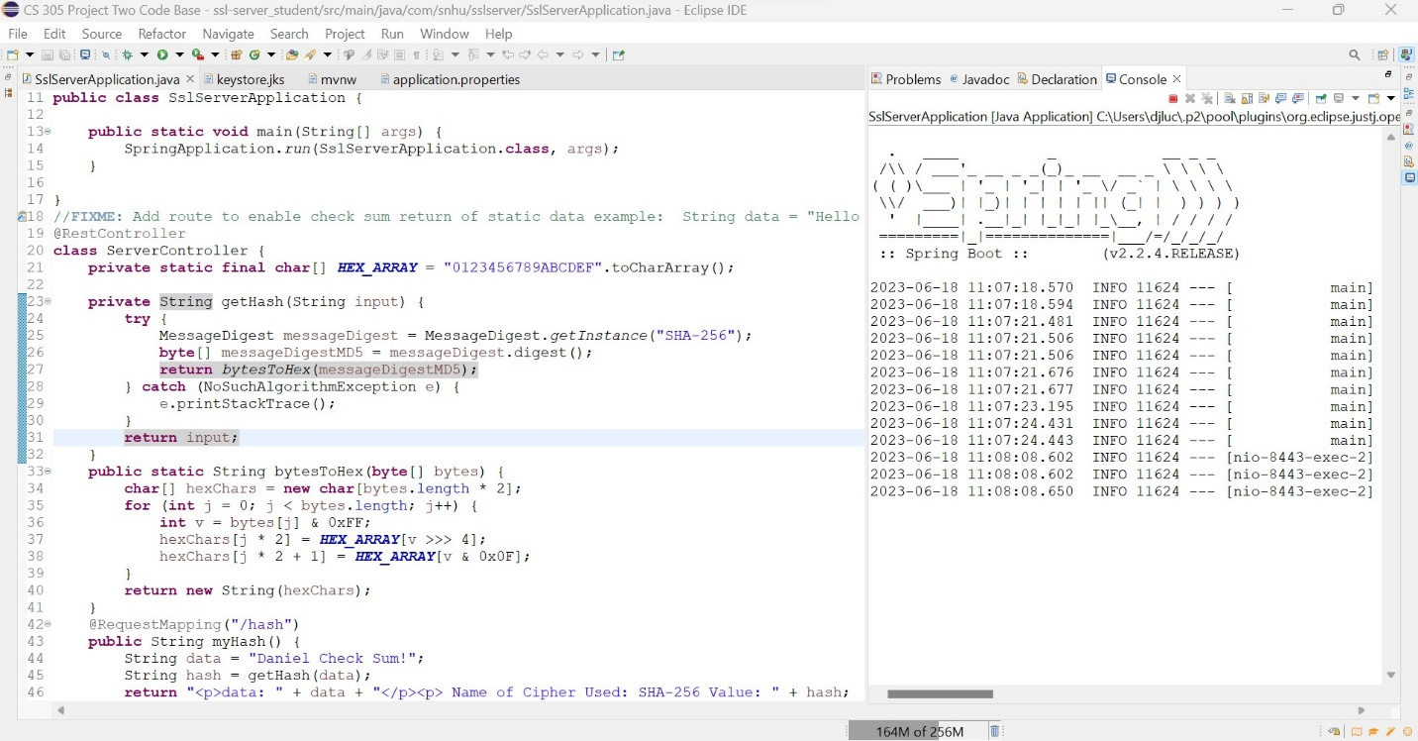
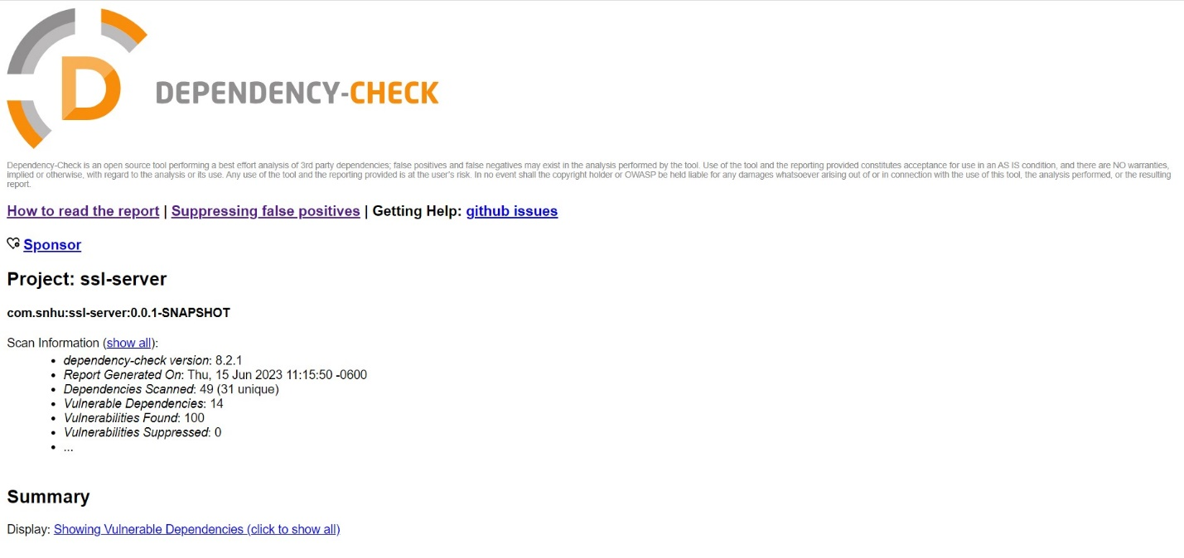

Functional Testing
Identify the software application's syntactical, logical, and security vulnerabilities by manually reviewing code.
- Complete this functional testing and include a screenshot of the refactored code, executed without errors, in your practices for secure software report.
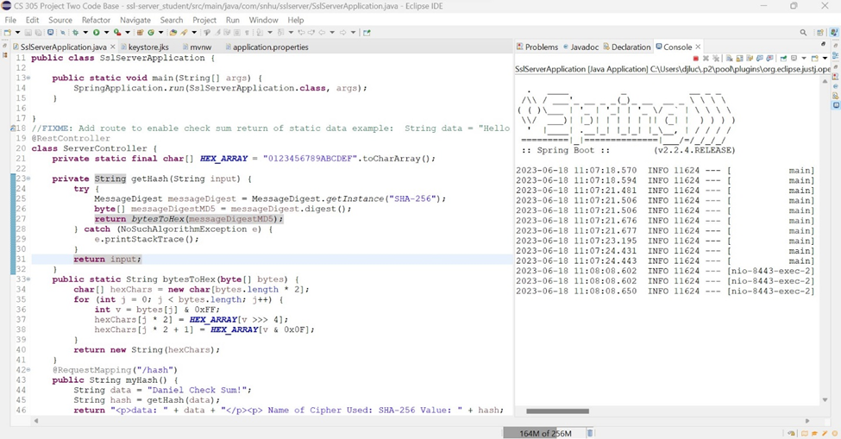

Summary
Discuss how the code has been refactored and how it complies with security testing protocols. In the summary of your practices for secure software report, be sure to address the following:
- Refer to the Vulnerability Assessment Process Flow Diagram. Highlight the areas of security that you addressed by refactoring the code.
- Discuss your process for adding layers of security to the software application.
The areas of security that I addressed in this project were code quality, server/client, and cryptography. For code quality I accounted for security in coding practices and patterns by testing, reviewing, and inspecting all the code for errors and vulnerabilities. For cryptography I implemented a 256-bit hashing algorithm to protect the sensitive data of the program. Even though the sensitive data was just my name and the name of the cipher. This could easily be changed to encrypt Artemis Financial sensitive information and protect their data. For Server/client I addressed this by integrating a security certificate and enforcing a TLS connection to the web application.

The first layer of security that was added to the project was an SSL certificate. This was to ensure that the site is safe and secure letting the users know that their communications are encrypted. This layer adds confidence to the users and builds their trust in Artemis Financial. The second layer of security added was SHA-256 encryption providing an extra layer of security. Even though the web application is encrypted, if it is hacked, the data stored within it will remain safe and secure. The final layer of security added was HTTPS enforcement. This ensures that if a user interacts with the web application, it will be encrypted and provide protection for both the server and the client.

Industry Standard Best Practices
Explain how you applied industry standard best practices for secure coding to mitigate against known security vulnerabilities. Be sure to address the following:
- Explain how you used industry standard best practices to maintain the software application’s current security.
- Explain the value of applying industry standard best practices for secure coding to the company’s overall wellbeing.
The best practices for maintaining the current security of the software application would be regular dependency checks to look for new vulnerabilities. Input validation for any input taken from users and regular coding reviews to make sure any changes to the code are checked for errors or unforeseen interactions. Finally, a solid API that allows specific things to be done and makes it easy and clear to users what to do and how to do it. It is important to maintain these practices to keep the application secure and helps the company’s clients have a strong healthy relationship with them. This helps maintain the company’s well-being and improve its perception.

